# 2A) Planning – Content Map

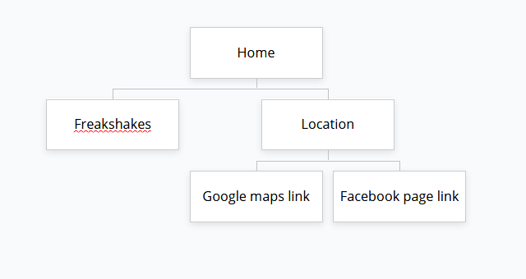

**2A) Planning – Page Sketch**

*2Aiv) Insert, or Paste your rough sketch here.*

# 2F) Publish your site

<https://s-assment.glitch.me/B2B%20assment/Web-page/Location.html>

# 3A) Testing in two browsers

*3A) Test the published website on at least two browsers:*

|  |  |
| --- | --- |
| **What I tested** | **Result** |
| Does webpage work in chrome | Yes |
| Does webpage work in Firefox | yes |
|  |  |

# 3B) Testing Plan (Specifications)

*3B) Test the site against the testing plan*

|  |  |
| --- | --- |
| **What I tested** | **Result** |
| 1. Must attractively *present* B2B colour scheme (“Light sea Green”, or #20B299) | The web page does this well. |
| 1. Must have three *functional* pages: Home page, Freakshakes page, and another page. | It does. |
| 1. Must contain B2B’s location (373 Church Street, PN) and hours (Tue – Sat 7:30am-4:30pm. Sun – Mon 8:30am – 3:30pm) | It does. |
| 1. At least one sentence on each page which is clearly *readable* and *legible*. | Yes. |
| 1. *Layout* an aside column, which is *formatted* to the right-hand side of all pages. | Yes. |
| 1. At least two *Media/images* of their food or drinks on the site. (Images provided) | Yes. |
| 1. *External Hyperlinks* to [facebook.com/B2BBakeryandCafe/](https://www.facebook.com/B2BBakeryandCafe/) and [B2B’s location on google maps](https://www.google.com/maps/place/B2B+Bakery/@-40.3563407,175.6134476,17z/data=!3m1!4b1!4m5!3m4!1s0x6d41b2da8f1ff159:0x6b1163b053bcd7ea!8m2!3d-40.3563407!4d175.6134476?hl=en). | Yes. |
|  |  |
|  |  |
|  |  |

# 4A) Evaluation – Target Audience

Does the webpage meet the requirements for the target audience (People of Palmerston North who buy food and drinks at bakeries). Yes, the webpage is online and ready to use showing some of the main ingredients and main food that they sell.

# 4B) Evaluation – Specifications

Does the webpage met the requirements in the specs well? Yes I think it does as the webpage for fills all specs and makes use of the css colour scheme well making the webpage look nice.